Continuing Education (CE) Language
Association of Ringside Physicians /ARP
2023 ARP Annual Conference
Jun 3-5, 2023

Joint Accreditation Statement
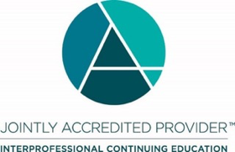
In support of improving patient care, this activity has been planned and implemented by Amedco LLC and Association of Ringside Physicians. Amedco LLC is jointly accredited by the Accreditation Council for Continuing Medical Education (ACCME), the Accreditation Council for Pharmacy Education (ACPE), and the American Nurses Credentialing Center (ANCC), to provide continuing education for the healthcare team.
Amedco Joint Accreditation #4008163.

Physicians (ACCME) Credit Designation
Amedco LLC designates this live activity for a maximum of 13.50 AMA PRA Category 1 CreditsTM. Physicians should claim only the credit commensurate with the extent of their participation in the activity.

